1. (a) Write a program in assembly language to print single character on screen.

Code

.MODEL SMALL

.STACK 100H

.DATA

char db 'A'

.CODE

MAIN PROC

MOV AX, @DATA

MOV DS, AX

MOV AH, 02H

MOV DL, char

INT 21H

MOV AH, 4CH

INT 21H

MAIN ENDP

END MAIN

(b) Write an assembly language program to convert an upper-case letter to the

corresponding lower-case letter.

Code

.MODEL SMALL

.STACK 100H

.DATA

upper db 'A'

lower db ?

.CODE

MAIN PROC

MOV AX, @DATA

MOV DS, AX

MOV AL, upper

ADD AL, 32

MOV lower, AL

MOV AH, 02H

MOV DL, lower

INT 21H

MOV AH, 4CH

INT 21H

MAIN ENDP

END MAIN

Output: 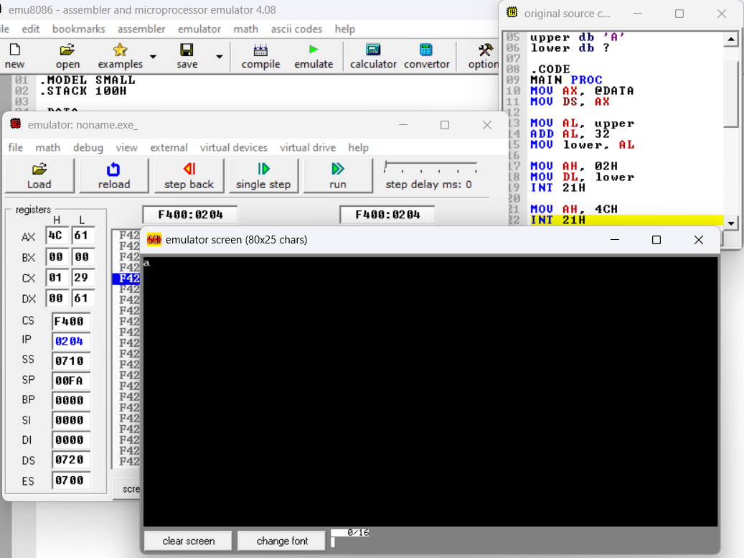

Practice set:

2.

(a) Write a program in assembly language to print multiple characters on screen.

Code

.MODEL SMALL

.STACK 100H

.DATA

msg db 'Hello, World!$'

.CODE

MAIN PROC

MOV AX, @DATA

MOV DS, AX

LEA DX, msg

MOV AH, 09H

INT 21H

MOV AH, 4CH

INT 21H

MAIN ENDP

END MAIN

Output:

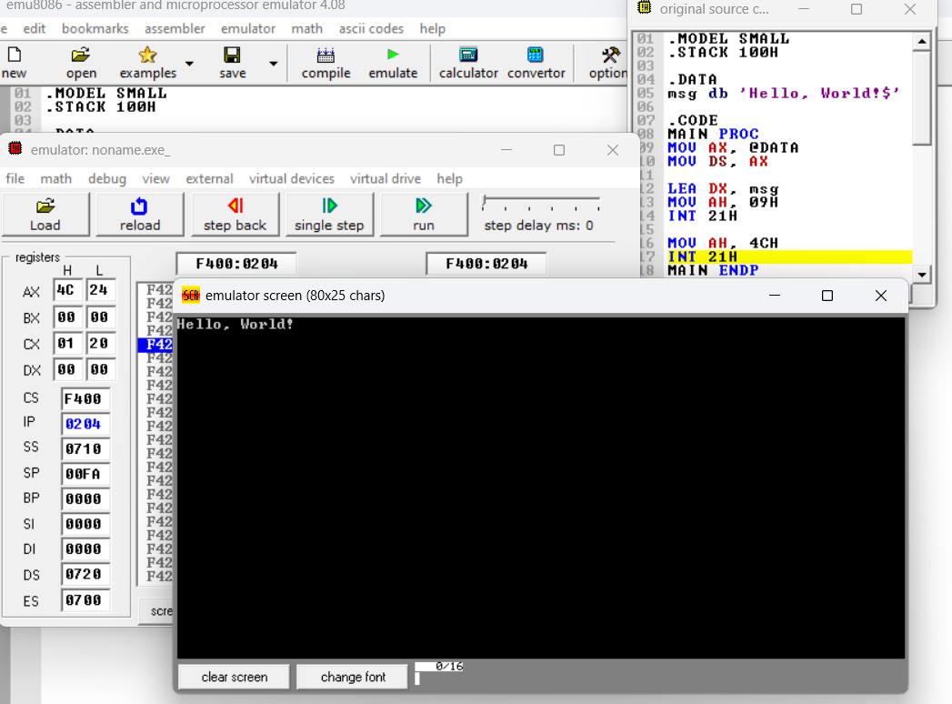

(b) Write an assembly language program to convert a lower-case letter to the

corresponding upper-case letter.

Code

.MODEL SMALL

.STACK 100H

.DATA

lower db 'b'

upper db ?

.CODE

MAIN PROC

MOV AX, @DATA

MOV DS, AX

MOV AL, lower

SUB AL, 32

MOV upper, AL

MOV AH, 02H

MOV DL, upper

INT 21H

MOV AH, 4CH

INT 21H

MAIN ENDP

END MAIN

Output:

